QUESTION 5:

ONLINE COURSE RESERVATION SYSTEM

CLASS DIAGRAM:

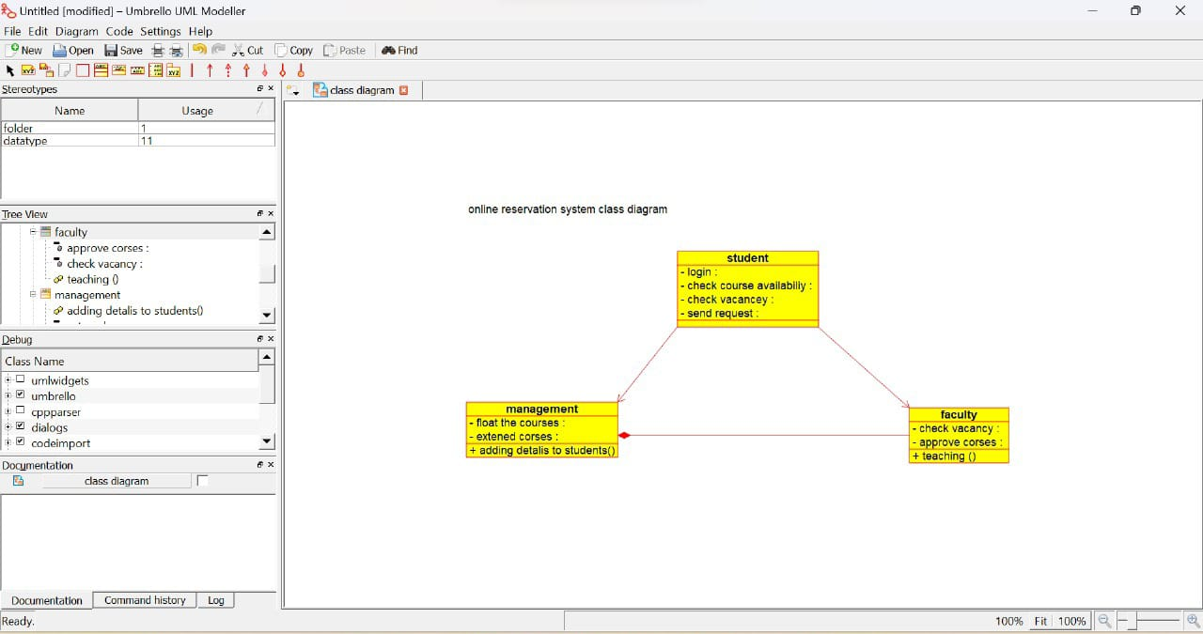

COLLABRATION DIAGRAM:

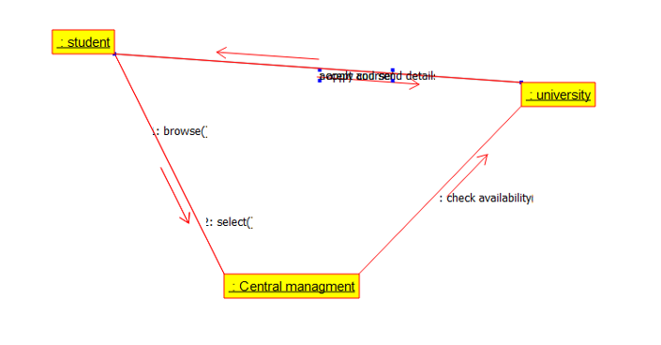

ACTIVITY DIAGRAM:

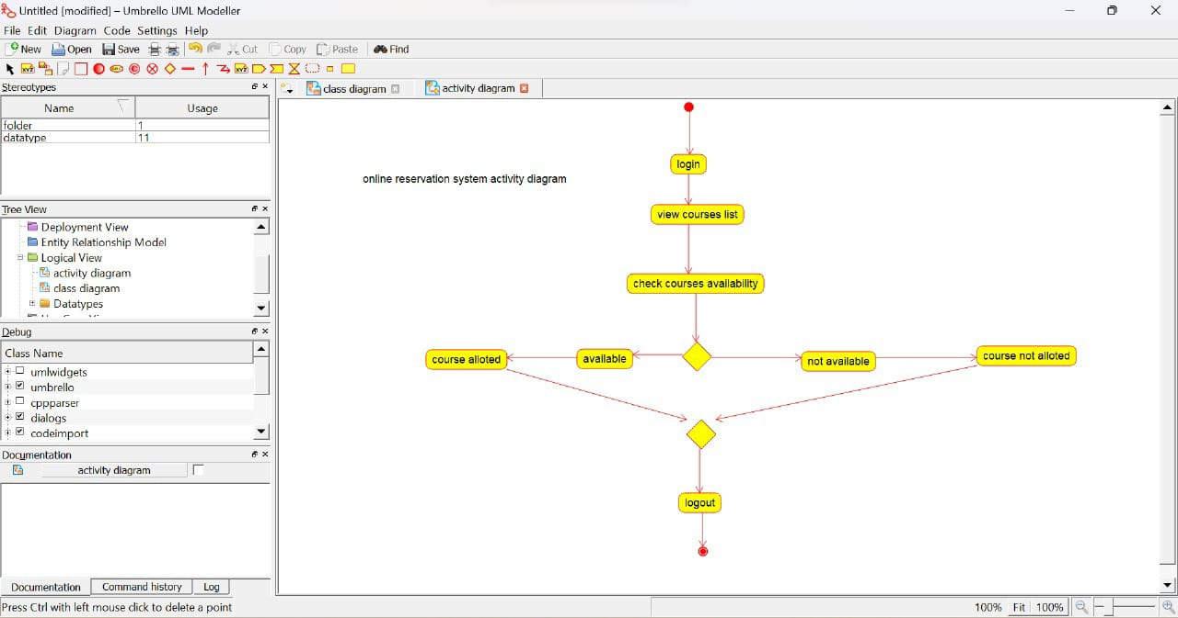

DEPLOYMENT DIAGRAM: